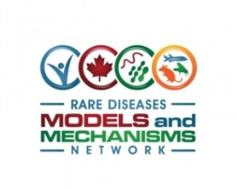

Application for Renewal of RDMM Catalyst Grants
This application is to be used by the Network’s Scientific Advisory Committee (SAC) to determine as to whether to provide an additional year of funding ($25,000) for already completed projects. At least 9 months of the initial project period must have been completed before submitting an application for additional funds. Applications should be submitted by the model organism investigator in collaboration with the clinician scientist involved.

Application Procedure: Requests must not exceed 2 pages using the attached application. Please submit: Two page application by email to: info@rare-diseases-catalyst-network.ca. You will receive a submission confirmation email. Each application will be reviewed by the Scientific Advisory Committee (SAC) and a decision to award additional funding for already completed projects will generally be available within 2 weeks. For further enquiries, please contact info@rare-diseases-catalyst-network.ca.
APPLICANT
Name | Faculty Appointment & Institutional Affiliation | Email | Telephone

GENE NAME: | DATE OF APPLICATION:
Have you been able to complete your project with the catalyst grant RDMM has awarded? Y/N

SUMMARY OF OUTCOMES OF ORIGINAL PROJECT (1/2-page)
Provide summary of the relevant outcomes, including generation of model organism(s), phenotypic analyses, and results together with interpretation. Briefly discuss any potential biological/mechanistic insights and/or therapeutic avenues that may be obtained from the studies.
If you have not completed the original proposed work with the previously issued budget, please list reasons why.
PROPOSED PROJECT (2/3 page)
Provide justification for continued work on the original project objectives or on the new project direction including details of the experiments to be conducted. Include the new deliverables.
BUDGET (1/3 page)
Enumerate the budget items (salary, reagents, services, etc.) specifically relevant for this proposal
REFERENCES (up to 5; include any submitted manuscripts related to the originally proposed project).

